Lab 4.2.2.6 Building an Ethernet Straight-through Cable

1. Objectives

* Build a Category 5 or Category 5e (CAT 5 or 5e) Unshielded Twisted Pair (UTP) Ethernet network patch cable or patch cord.
* Test the cable for continuity and correct pinouts, the correct color of wire on the right pin. Pinout: A diagram or table that describes the purpose of each [pin](http://www.webopedia.com/TERM/p/pin.html) in a [connector](http://www.webopedia.com/TERM/p/connector.html), or each wire in a cable.

1. Background

The cable constructed will be a four-pair, eight-wire, straight-through cable, which means that the color of wire on Pin 1 on one end of the cable will be the same as that of Pin 1 on the other end. Pin 2 will be the same as Pin 2, and so on. The cable will be wired to either TIA/EIA T568B or T568A standards for 10BASE-T Ethernet, which determines what color wire is on each pin. T568-B, also called AT&T specification, is more common in the U.S., but many installations are also wired to T568-A, also called ISDN.

Work in teams. The following resources will be required:

* One 0.6 to .9 m (2 to 3 ft) length of Cat 5 cabling per team
* Four RJ-45 connectors, two are extra for spares
* RJ-45 crimping tools to attach the RJ-45 connectors to the cable ends
* Ethernet cabling continuity tester which can test straight-thru or crossover type cables, T568-A or T568-B
* Wire cutters

#### Diagram showing both T568-A and T5568-B cabling wire colors

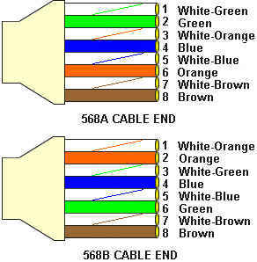

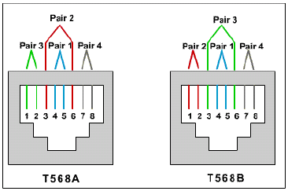

1. Build an Ethernet Straight-Thru Cable

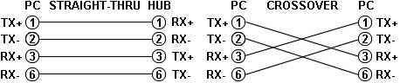

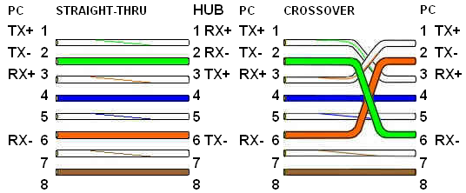

1. Test the Cable

**Fluke:** Insert the RJ-45 from one end of the cable into the UTP/FTP jack on the tester. Turn the dial to test. All conductors will be tested to verify they are not broken or shorted.

**Note:** This test does not verify that the pins are connected correctly from one end to the other.

For each test, insert the cable into the RJ-45 jack(s) of the cable tester. Record the results in the following table.

|  |  |  |  |  |
| --- | --- | --- | --- | --- |
|  | **Color or Cable**  **number** | **Category Type** | **Length of**  **cable** | **Test results**  **(Pass or Fail)** |
| Cable |  |  |  |  |